Gaidge Jellick
SNHU
CS - 499 - Computer Science Capstone
6/1/26

For this milestone, I made enhancements to my Weight Tracking application from CS-360. I wanted to adjust how data is held within the system (the databases) to make it a little more coherent as well as allow for live updating of any included data. I chose this artifact because I truly enjoyed this assignment and think it can hold more / be improved upon.

Old | New
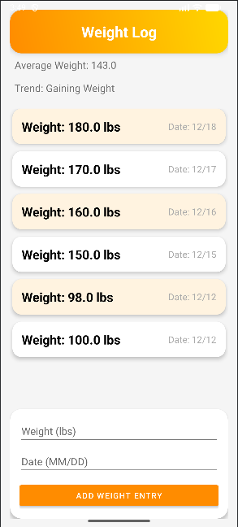 | 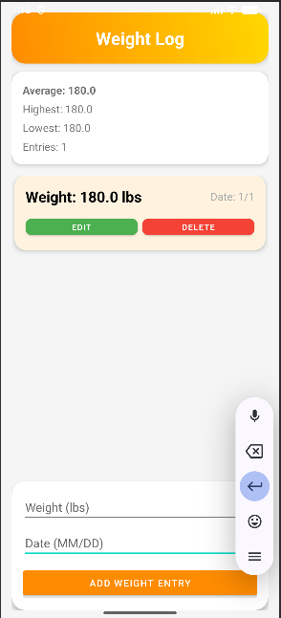

Now, to go over the changes I made.

Within Activity_Data.xml:
I added a better card for holding the trends data that I added in the previous enhancement, as well as made it more relevant.

Within DatabaseHelper.java:
I adjusted the system to use SQL-based information, removing the need for WeightEntry.java (simplifying the system's data handler).

Adjusted WeightAdapter.java:
I made adjustments to WeightAdapter.java to handle the new information, as well as hold the functions for editing an input and deleting one. (Live updates to the database).

Within item_weight.xml:
I changed around the layout, made more card/material-based buttons, as I like the look of them a lot for the system. I also added a couple more buttons, specifically the Delete and Edit buttons.

